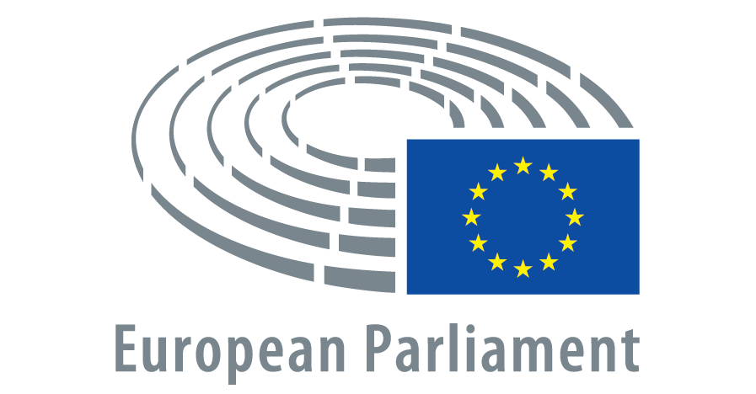
Rue Wiertz 60, B-1047 Brussels
Ms Ursula von der Leyen
President of the European Commission

December 2023

Dear President of the European Commission, Dear Ms von der Leyen,

It’s almost Christmas and for 600 days Johan Floderus, Swedish citizen and EU official (EEAS), has been arbitrarily detained in Tehran by the Islamic Republic of Iran. His imprisonment was reported in the New York Times on September 4th 2023 and was publicly confirmed by his family. Just recently, Johan’s father shared details about his living standards in a heart-wrenching interview published in the Guardian.

The conditions of his captivity blatantly disregard the United Nations Standard Minimum Rules for Treatment of Prisoners. Johan Floderus has been held for over 300 days in solitary confinement and does not have adequate access to food rations, fresh air and sunlight, medical checkups, and communication. He has been on hunger strikes at least five times.

We ask you to do whatever is in your power to bring Johan Floderus home before Christmas.

The European Commission has the moral duty and the diplomatic standing to strongly contribute to the efforts towards the liberation of Mr Floderus, more so as he is a member of the EU’s diplomatic corps. We would highly appreciate a personal commitment and effort from you, Ms. Von der Leyen, to address Mr. Floderus’s case and all other Europeans detained in Iran, and to contribute to the release of Mr. Floderus and all other detained Europeans before Christmas this year. Because in the spirit of Christmas, we all should look after one another and have to make sure that these Europeans are home with their family, not alone in an Iranian cell.

Yours respectfully,

Abir Al-Sahlani MEP
Bart Groothuis MEP

